1. **Sales Performance Analysis**

* **Total Sales by Sales Agent**: Find out which sales agents have the highest total sales.

SELECT sales_agent, SUM(close_value) AS Total_Sales

FROM sales_pipeline

WHERE deal_stage = 'Won'

GROUP BY sales_agent

ORDER BY SUM(close_value) DESC;

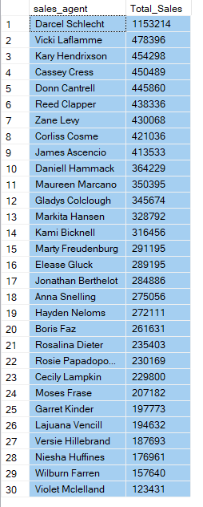

* **Total Sales by Product**: Determine which products are generating the most revenue.

SELECT Top(10) product, SUM(close_value) AS Total_Sales

FROM sales_pipeline

GROUP BY product

ORDER BY Total_Sales DESC;

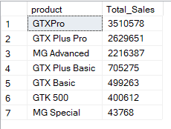

* **Sales by Region**: Analyze sales performance by regional office.

SELECT s.regional_office, SUM(p.close_value) AS Total_Sales

FROM sales_pipeline p

JOIN sales_teams s on s.sales_agent = p.sales_agent

WHERE p.deal_stage = 'Won'

GROUP BY s.regional_office

ORDER BY Total_Sales DESC;

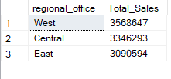

1. **Account Analysis**

* **Revenue Contribution by Account**: Find out which accounts contribute the most to revenue.

Select Top 10 account, SUM(close_value) As Total_revenue

from [CRM].[dbo].[sales_pipeline]

where deal_stage='Won'

group by account

order by Total_revenue DESC

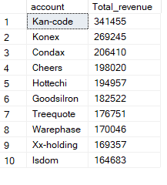

* **Sector-wise Revenue Distribution**: Analyze revenue distribution across different sectors.

Select a.sector, Sum(p.close_value) As Total_revenue

from sales_pipeline p

join accounts a on p.account = a.account

where p.deal_stage='Won'

group by a.sector

order by Total_revenue DESC

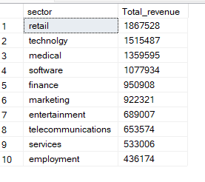

1. **Product Performance Analysis**

* **Top Performing Products**: Identify top-selling products.

SELECT product, SUM(close_value) AS total_sales

FROM sales_pipeline

WHERE deal_stage = 'Won'

GROUP BY product

ORDER BY total_sales DESC;

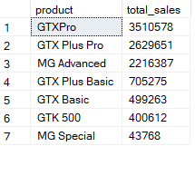

* **Product Sales by Account**: Analyze which accounts are purchasing specific products.

SELECT Top (10) account, product, SUM(close_value) AS total_sales

FROM sales_pipeline

WHERE deal_stage = 'Won'

GROUP BY account, product

ORDER BY total_sales DESC;

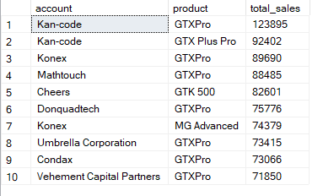

1. **Employee and Office Analysis**

* **Average Revenue per Employee by Account**: Calculate the average revenue generated per employee for each account.

SELECT Top (10) a.account, a.employees, SUM(p.close_value) / a.employees AS revenue_per_employee

FROM accounts a

JOIN sales_pipeline p ON a.account = p.account

WHERE p.deal_stage = 'Won'

GROUP BY a.account, a.employees

ORDER BY revenue_per_employee DESC;

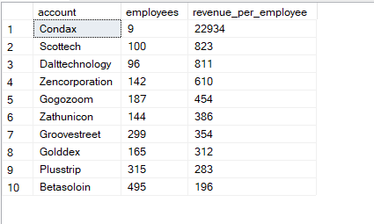

* **Revenue by Office Location**: Determine which office locations generate the most revenue.

SELECT a.office_location, SUM(p.close_value) AS total_revenue

FROM accounts a

JOIN sales_pipeline p ON a.account = p.account

WHERE p.deal_stage = 'Won'

GROUP BY a.office_location

ORDER BY total_revenue DESC;

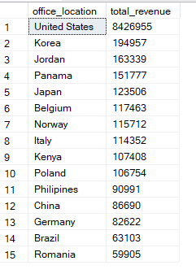

1. Time-Based Analysis

* **Monthly Sales Trends**: Analyze sales trends over time.

SELECT

CAST(YEAR(close_date) AS VARCHAR(4)) + '-' + RIGHT('0' + CAST(MONTH(close_date) AS VARCHAR(2)), 2) AS month,

SUM(close_value) AS total_sales

FROM sales_pipeline

WHERE deal_stage = 'Won'

GROUP BY YEAR(close_date), MONTH(close_date)

ORDER BY YEAR(close_date), MONTH(close_date);

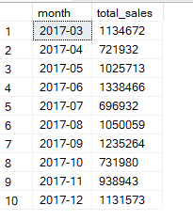

* **Sales Cycle Duration**: Calculate the average time taken to close deals.

SELECT AVG(DATEDIFF(day, engage_date, close_date)) AS average_sales_cycle

FROM sales_pipeline

WHERE deal_stage = 'Won';



1. Deal Analysis

* **Lost Deals Analysis**: Understand reasons for lost deals and identify patterns.

SELECT Top (10) sales_agent, COUNT(*) AS lost_deals, SUM(close_value) AS potential_loss

FROM sales_pipeline

WHERE deal_stage = 'Lost'

GROUP BY sales_agent

ORDER BY lost_deals DESC;

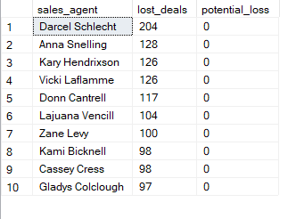

* **Deals by Sales Agent and Product**: Analyze which sales agents are successful with specific products.

SELECT Top (10) sales_agent, product, COUNT(*) AS deals_count, SUM(close_value) AS total_sales

FROM sales_pipeline

WHERE deal_stage = 'Won'

GROUP BY sales_agent, product

ORDER BY total_sales DESC;

